William Chirciu  
CSC 555 Project Phase 2

USED 4 NODE CLUSTER:

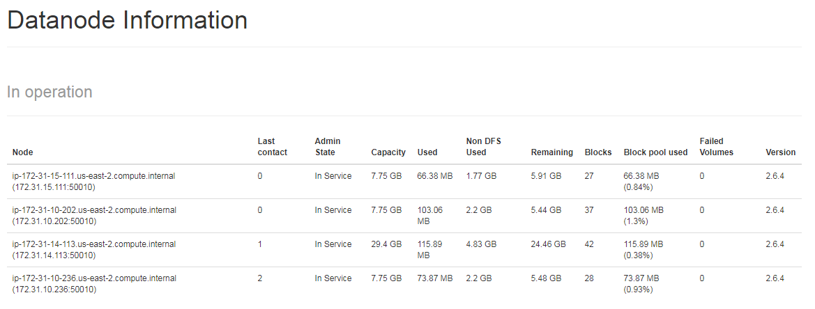

PART 1: DATA TRANSFORMATION

**Hadoop Streaming**

**Python Code:  
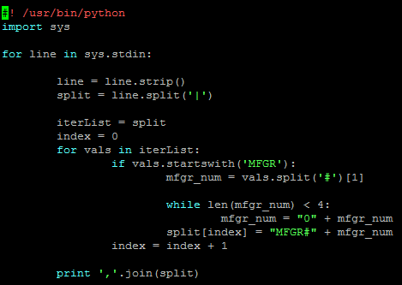**

**Command:**



**After Running Job:**

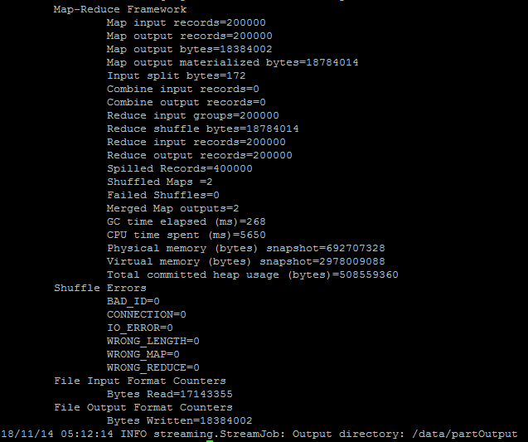

**Some Output:**

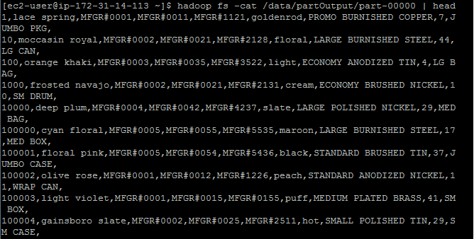

**HIVE**

**Python Code:**

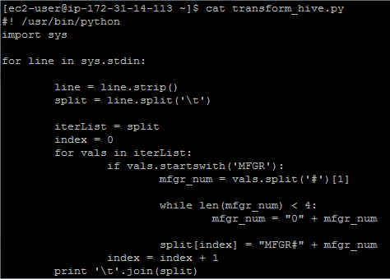

**Commands:**

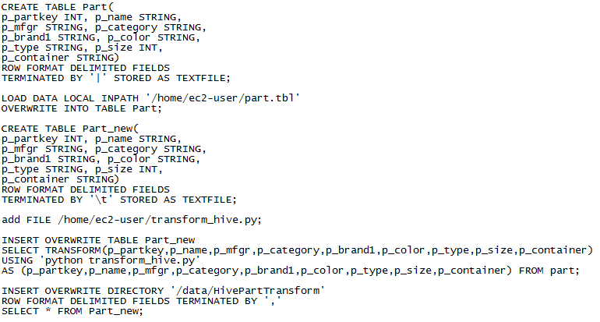

**After running job:**

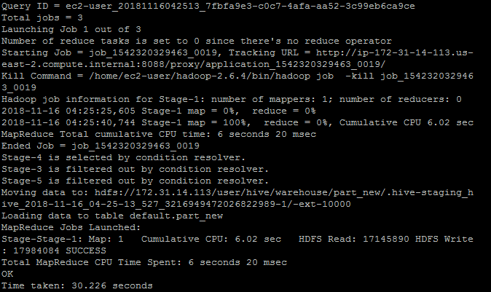

**Output:**

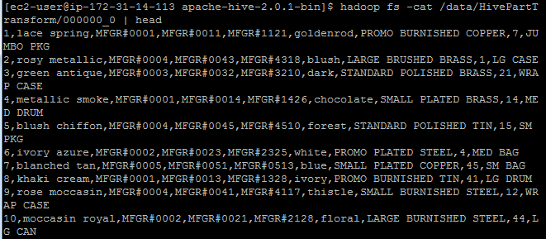

**PIG**

**Commands:**

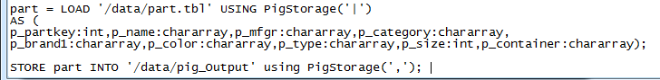

**After running job:**

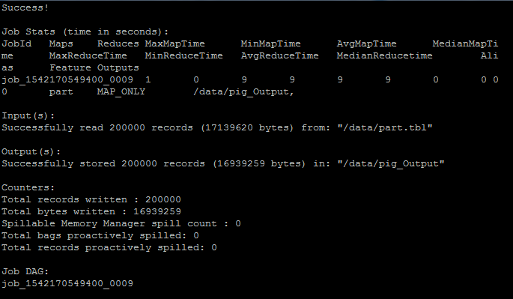

**Output:**

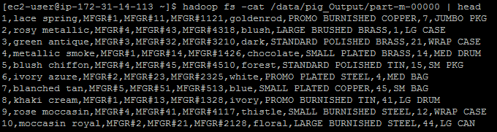

PART 2: Queries

**Hadoop Streaming**

***Joining Customer and Lineorder Tables***

**Mapper:**

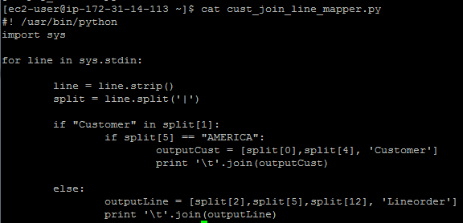

**Reducer:**

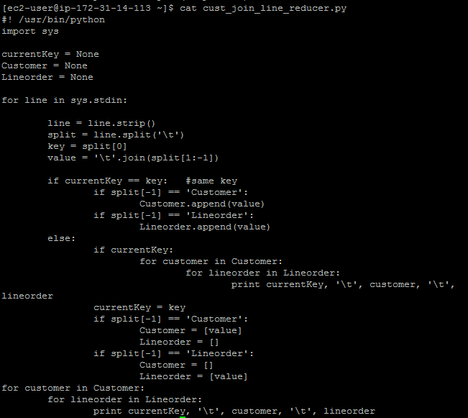

**Command Line:**



**After running job:**

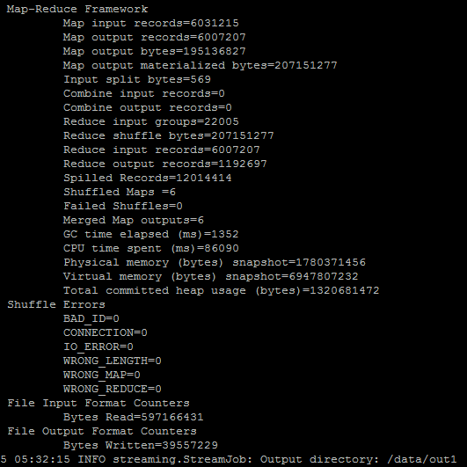

***Joining CjL and dwdate tables***

**Mapper:**

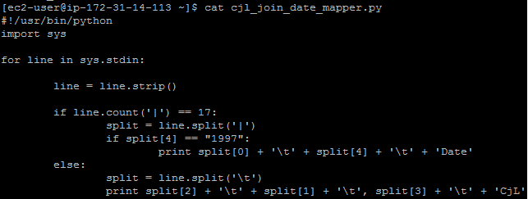

**Reducer:**

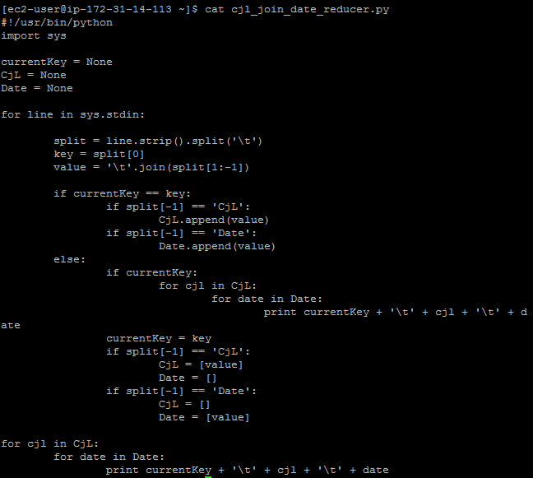

**Command Line:**



**After running job:**

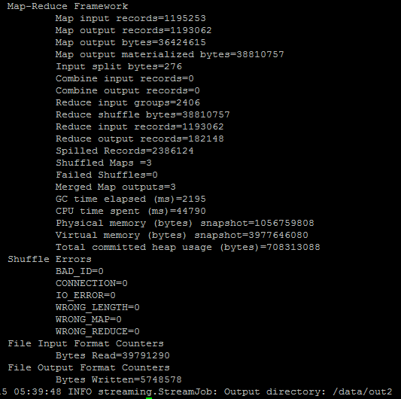

***Group By***

**Mapper:**

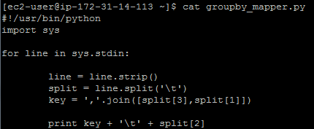

**Reducer:**

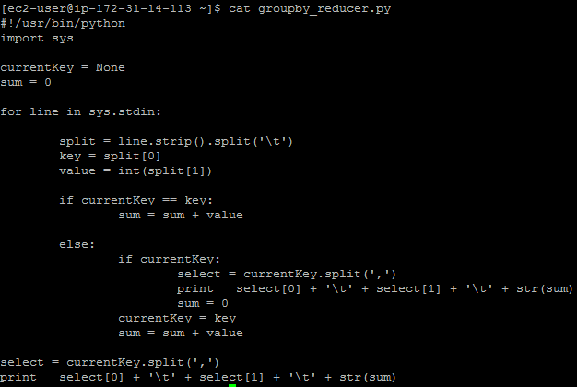

**Command Line:**



**After running job:**

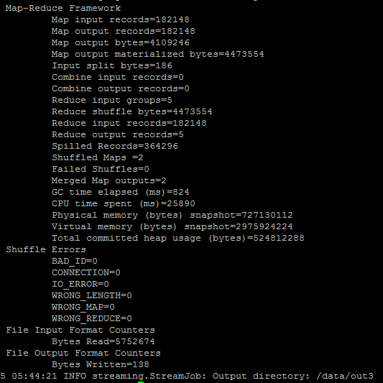

**Final Output:**

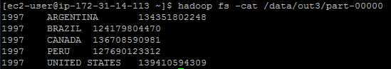

**HIVE**

**Command Line:**

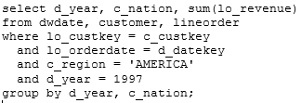

**After running job:**

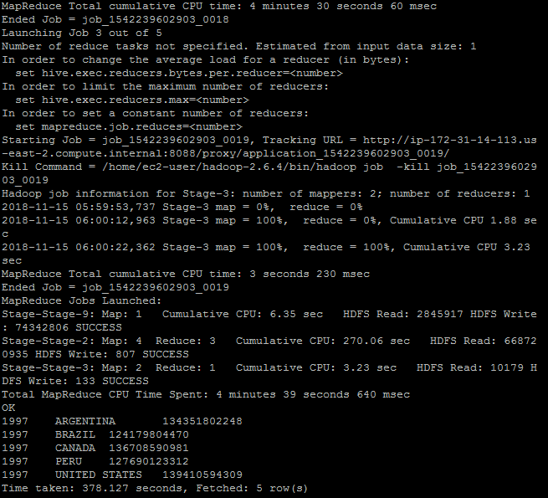

**PIG**

**Command Line:**

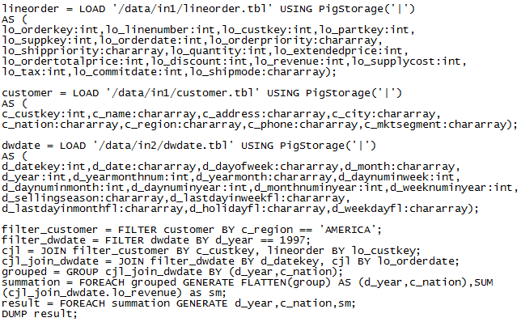

**After running job:**

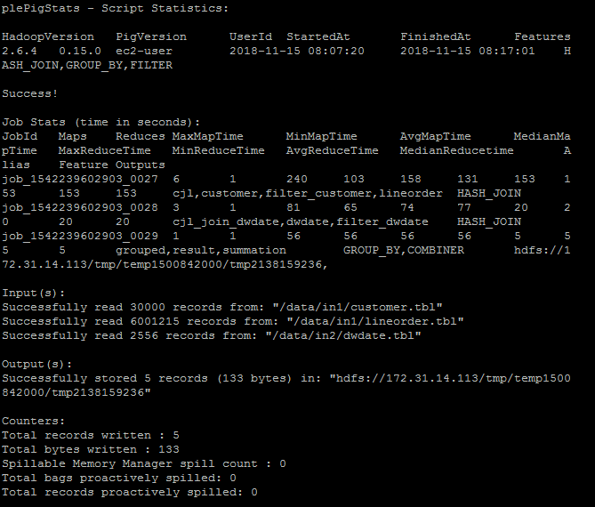

**Output:**

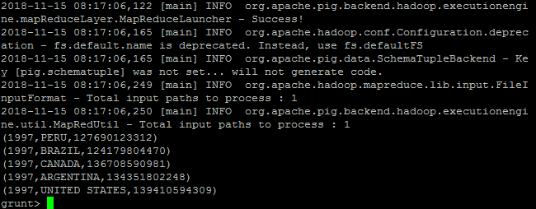

PART 3: Clustering

**Creating Numeric File:**

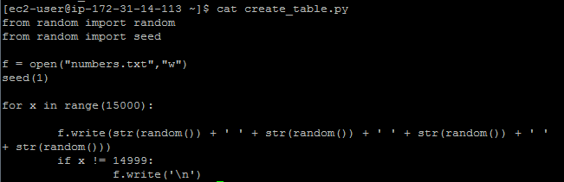

**First 10 lines in Numeric File:**

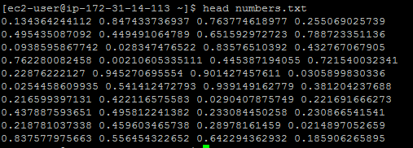

**Part A : Using ‘numbers.txt’ as input data**

**After running** time mahout org.apache.mahout.clustering.syntheticcontrol.kmeans.Job

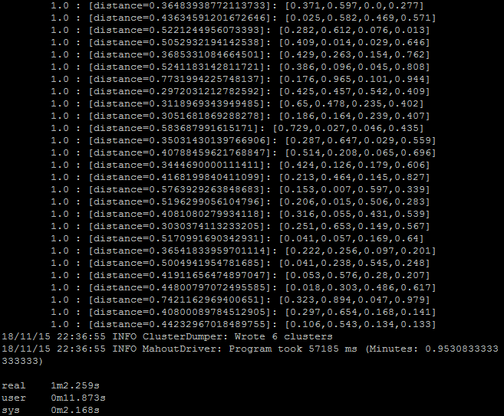

**After running** mahout clusterdump --input output/clusters-1-final --pointsDir output/clusteredPoints --output clusteranalyze.txt

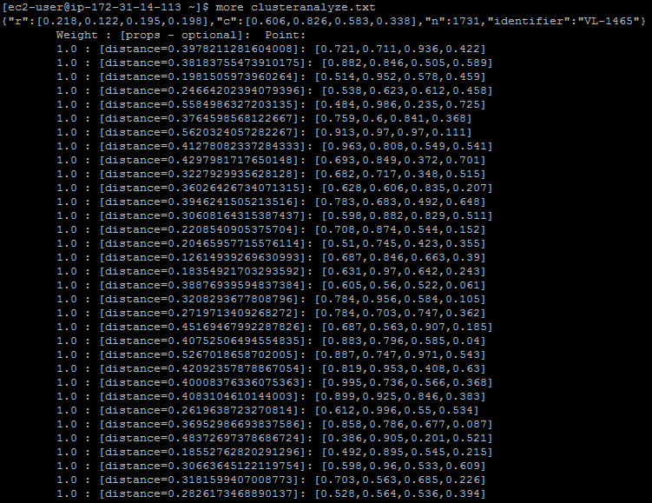

**Part B**

**Original random centers:**

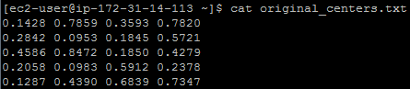

**Mapper: Distances calculated using Euclidean distance**

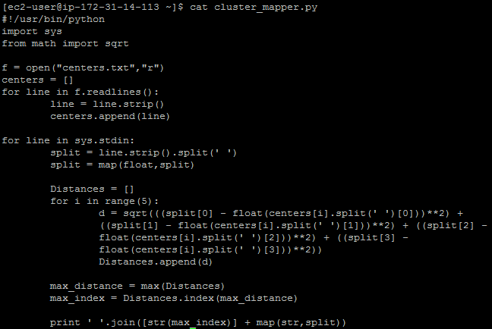

**Reducer:**

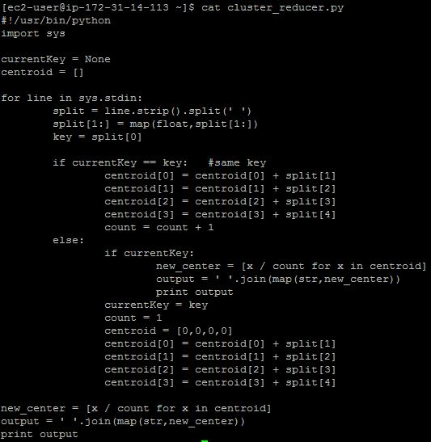

**1st Iteration**

**Command Line:**



**After running job:**

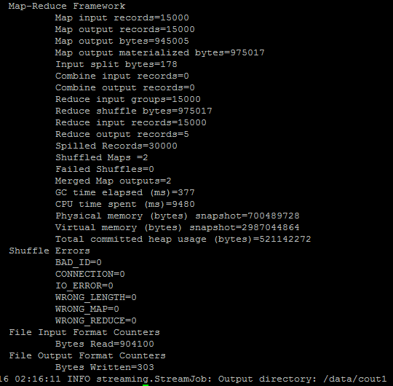

**New cluster centers for next iteration:**

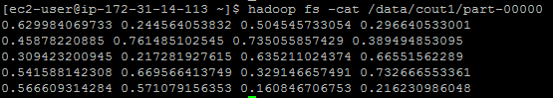

**2nd Iteration**

**Command line:**



**After running job:**

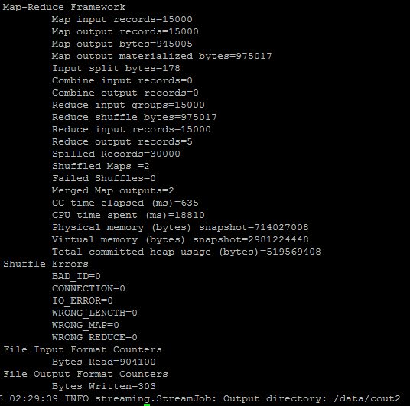

**New cluster centers for next iteration:**

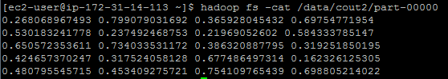

**3rd Iteration**

**Command line:**



**After running job:**

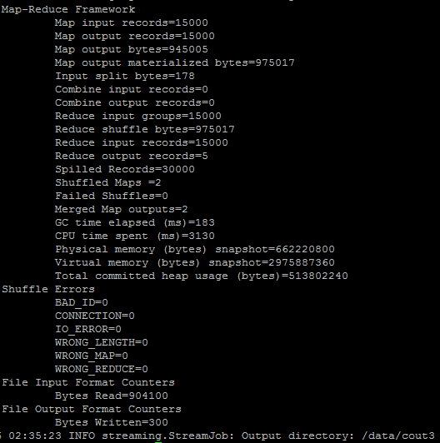

**Final cluster centers:**

